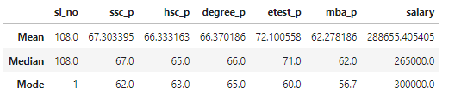

**Key Insights:**

**Mean:**

The average salary is ₹288,655, with an average SSC score of 67.30%, HSC score of 66.33%, degree score of 66.37%, entrance test score of 72.10%, and MBA score of 62.28%.

**Median:**

The median salary is ₹265,000, indicating that half the data falls below this amount. The median academic scores are generally close to their means, except for the entrance test score, which has a median of 71%.

**Mode:**

The mode (most frequent value) for salary is ₹300,000, suggesting a concentration of salaries around this value. Similarly, academic scores cluster around 62%-65%.